Experimental task n. 10

Pavel Ondračka
324363
8.04.2010

subject: Absorption of gamma radiation

Introduction: Gamma rays are electromagnetic radiation of high frequency (very short wavelength). They are produced by sub-atomic particle interactions such as electron-positron annihilation, neutral pion decay, radioactive decay, fusion, fission or inverse Compton scattering in astrophysical processes. Gamma rays typically have frequencies above 1019 Hz, and therefore have energies above 100 keV and wavelength less than 10 picometers, often smaller than an atom. Gamma radioactive decay photons commonly have energies of a few hundred keV, and are almost always less than 10 MeV in energy.
γ rays can penetrate relatively easily through materials. Therefore, shielding from γ ra-
diation requires large amount of mass. γ photons are absorbed namely by three effects:
creation of electron-positron pairs, Compton scattering and photoeffect. Consequently, the
attenuation of γ radiation can be described by equation

task a) Measure the energy spectrum of Cs and calibrate the energy scale of the measured graph.
I succesfully calibrated energy scale with ¹³⁷ Cs which produces γ photons with energy 661.7 keV and I confirmed this calibration later when measuring ⁶⁰Co which produces protons with energies 1,1725 and 1,3325 MeV.

task b) Measure the absorption coefficients of γ radiation in three different
materials .
lean, aluminum and Plexiglas were used in this measurement. Only rays with energy 1,1725 MeV were measured, second peak at 1,3325 MeV was not. Measured values are compared to table values. (Values from the table μ_{m} were converted to μ according to equation μ_{m} = μ/ρ )

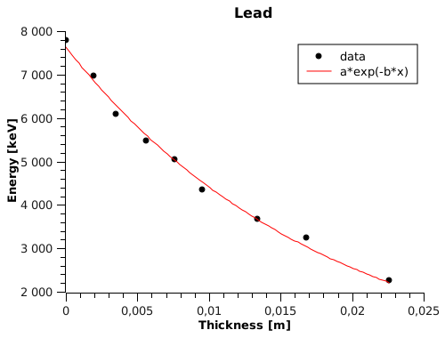

a = I₀ = 7600 ± 100 keV
b = μ = 55 ± 2 m⁻¹

Table values: 1Mev - μ = 79,72 ; 1,5 MeV - μ = 62,37

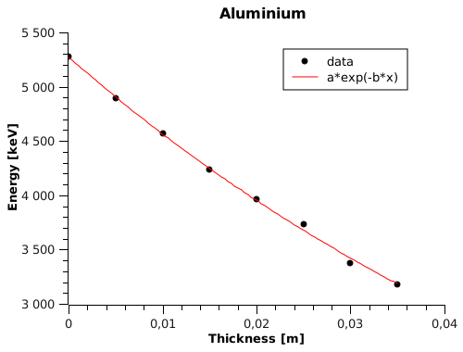
a = I₀ = 5270 ± 20 keV
b = μ = 14,4 ± 0,2 m⁻¹

Table values: 1Mev - μ = 16,57 ; 1,5 MeV - μ = 13,5

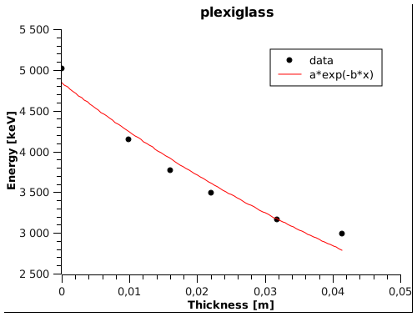

a = I₀ = 4840 ± 100 keV
b = μ = 13 ± 1 m⁻¹

Table values: unknown

Conclusion: I was able to successfully calibrate energy scale and measure absorption coefficient of three materials. I was able to confirm that intensity decrease exponentially with increasing material thickness. When comparing calculated values to values from table absorption coefficient for aluminum should be in concordance with table values. However lean absorption coefficient is lower then expected. Reason for this low value are unknown to me. Possible reasons for mistakes can be that because of background radiation, I was sometimes not able to determine the exact border of a energy peak.

